**Experiment No.: 2**

**Build a simple network topology and configure it for static routing protocol**

* **Aim:** Build a simple network topology and configure it for static routing protocol using packet tracer.
* **Objectives:** To introduce concepts and fundamentals of network topologies and their configurations.
* **Outcomes:** The learner will be able to
* Analyze the functioning of various networking devices.
* Use the simulation tool Cisco Packet Tracer for building networks.
* Recognize the need for topology.
* **Hardware/Software required:** Cisco Packet Tracer
* **Theory**

Setting the topology

1. Drag and drop the router/switch/computer from the bottom of the screen

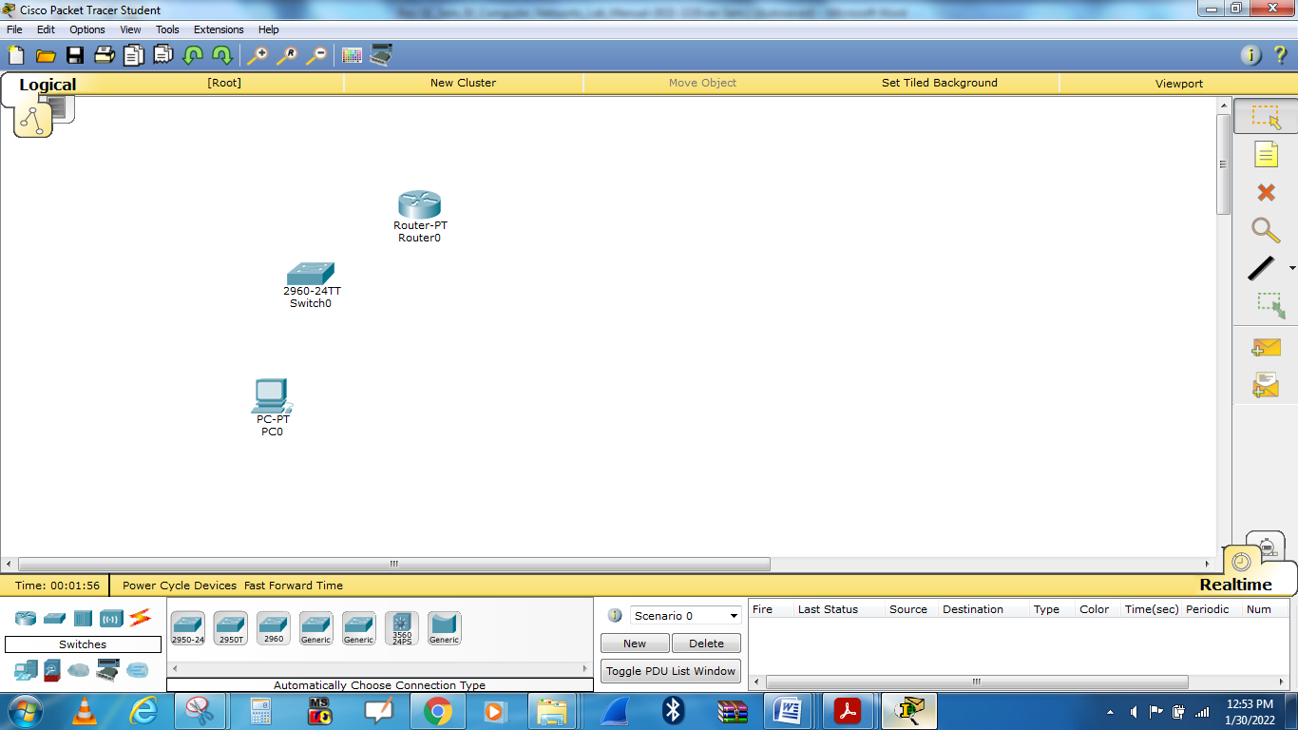

2. Select **end devices** from the bottom left-hand corner and drag it to the sandbox screen.

3.  Select **connections** from the same bottom left-hand corner. When you connect like-devices (Such as a router and computer)  you use a crossover cable, so you should select **Automatically choose connection** from the second menu to the immediate right. Click on PC0 to Switch0 and *Router0*.

1. Repeat step number 3 to connect **PC1,PC2,PC3, and Switch0 to Router0.**

**Configuring the router in packet tracer**

1. Next we have to open the Ethernet ports to allow communication. Although they are physically connected, they are in a state that is known as being in **administrative shut down**. Now click on the **CLI** tab to access the configuration menu.

--- System Configuration Dialog ---

Continue with configuration dialog? [yes/no]: n

Press RETURN to get started!

Router>**enable**

Router#**configure terminal**

Enter configuration commands, one per line. End with CNTL/Z.

Router(config)#**interface FastEthernet0/0**

Router(config-if)#**no shutdown**

%LINK-5-CHANGED: Interface FastEthernet0/0, changed state to up

%LINEPROTO-5-UPDOWN: Line protocol on Interface FastEthernet0/0, changed state to up

Router(config-if)#**ip address 192.168.1.1 255.255.255.0**

Router(config-if)#**exit**

Router(config)#**interface Serial2/0**

Router(config-if)#**no shutdown**

%LINK-5-CHANGED: Interface Serial2/0, changed state to up

%LINEPROTO-5-UPDOWN: Line protocol on Interface Serial2/0, changed state to up

Router(config-if)#**ip address 20.0.0.1 255.0.0.0**

Router(config-if)#**exit**

Router(config)#**ip route 192.168.2.0 255.255.255.0 20.0.0.2**

Router(config)#**end**

Router#copy running-config startup-config

Destination filename [startup-config]?

Building configuration...

[OK]

Router#

%SYS-5-CONFIG_I: Configured from console by console

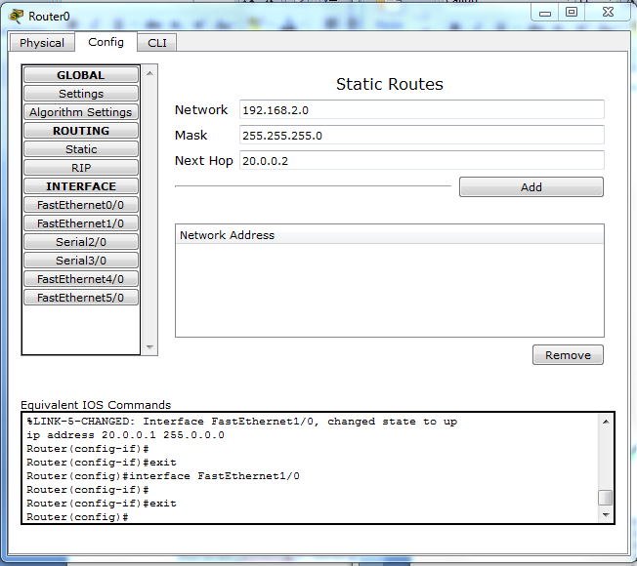

Add network

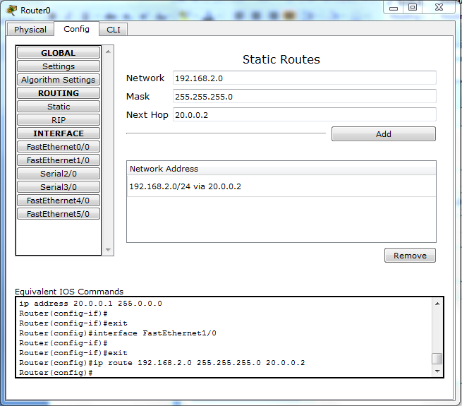

Go to **Config >settings** save configuration of static routing.

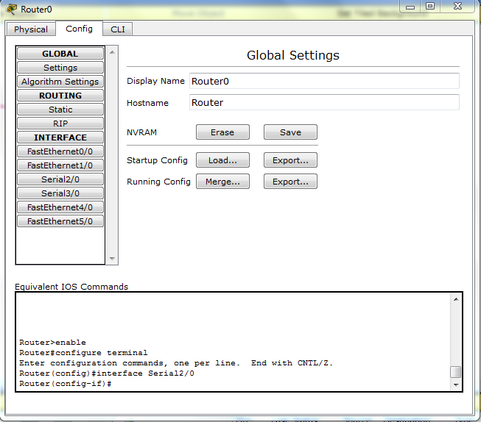

**Computer configuration**

1. Click on PC0 and go to Desktop
2. Choose IP configuration and configure IP address as 192.168.1.2 , click on subnet mask, subnet mask address will come automatically.
3. Default Gate way is Rourt0 IP address, configure this address as 192.168.1.1.
4. Close configuration.
5. Repeat step 1 to Step 4 to configure Ip addresses to PC1 to PC3.

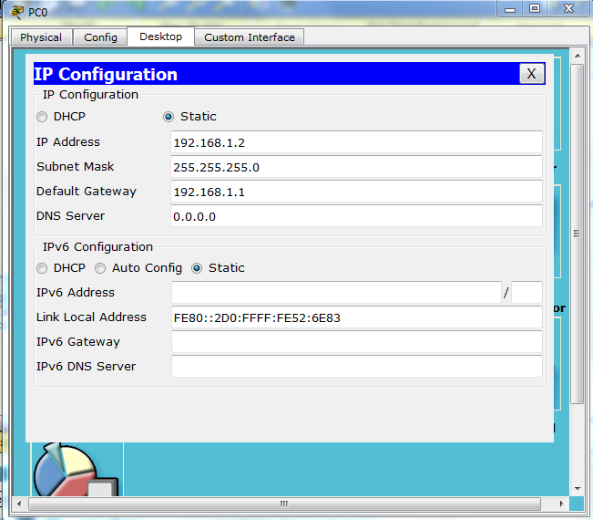

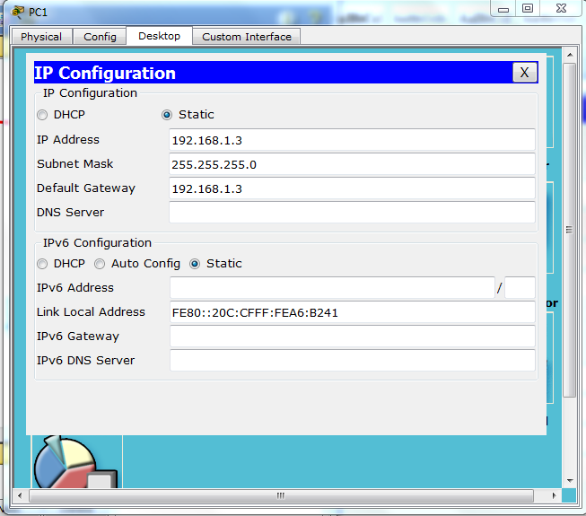

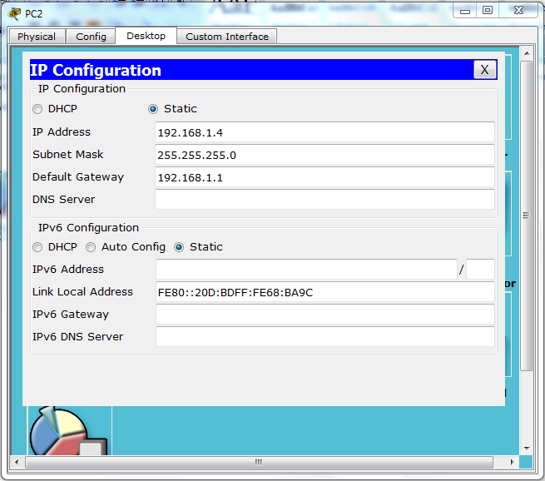

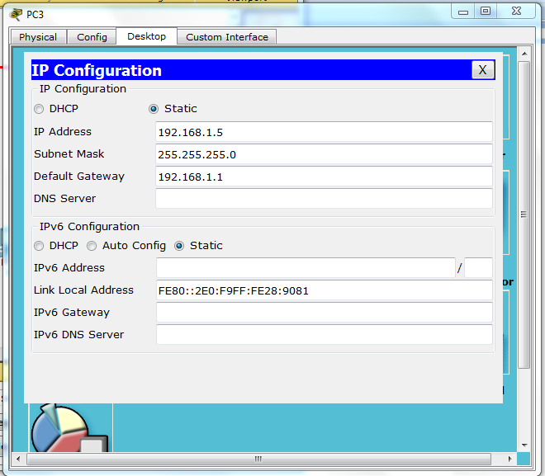

**Router1 Configuration**

--- System Configuration Dialog ---

Continue with configuration dialog? [yes/no]: n

Press RETURN to get started!

Router>**enable**

Router#**configure terminal**

Enter configuration commands, one per line. End with CNTL/Z.

Router(config)#**interface FastEthernet0/0**

Router(config-if)#**no shutdown**

%LINK-5-CHANGED: Interface FastEthernet0/0, changed state to up

%LINEPROTO-5-UPDOWN: Line protocol on Interface FastEthernet0/0, changed state to up

Router(config-if)#**ip address 192.168.2.1 255.255.255.0**

Router(config-if)#**exit**

Router(config)#**interface Serial2/0**

Router(config-if)#**no shutdown**

%LINK-5-CHANGED: Interface Serial2/0, changed state to up

%LINEPROTO-5-UPDOWN: Line protocol on Interface Serial2/0, changed state to up

Router(config-if)#**ip address 20.0.0.2 255.0.0.0**

Router(config-if)#**exit**

Router(config)#**ip route 192.168.1.0 255.255.255.0 20.0.0.1**

Router(config)#**end**

Router#copy running-config startup-config

Destination filename [startup-config]?

Building configuration...

[OK]

Router#

%SYS-5-CONFIG_I: Configured from console by console

**Static Routing**

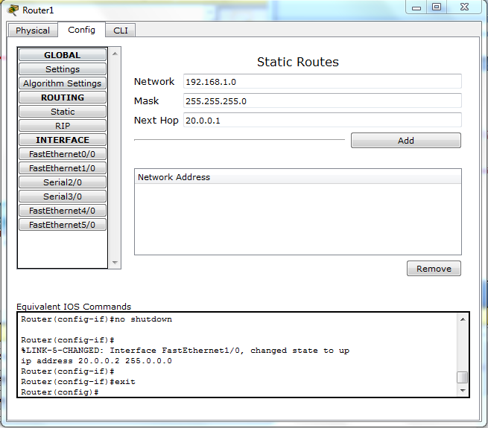

Add network

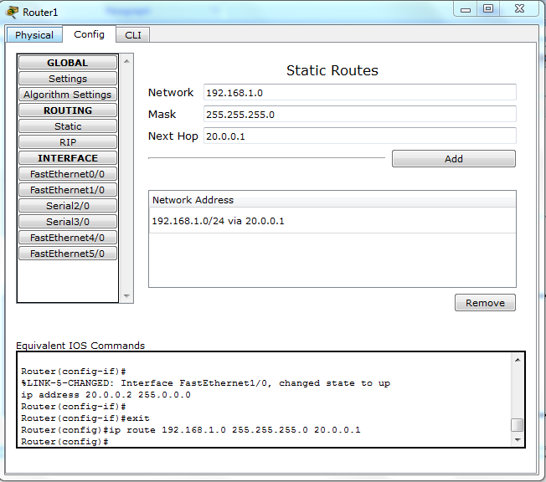

Go to **Config >settings** save configuration of static routing.

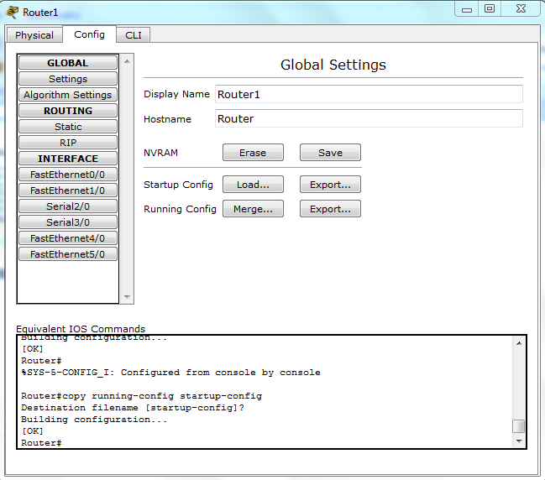

**Computer configuration**

1. Click on PC4 and go to Desktop
2. Choose IP configuration and configure IP address as 192.168.2.2 , click on subnet mask, subnet mask address will come automatically.
3. Default Gate Way is Rourt1 IP address, configure this address as 192.168.2.1.
4. Close configuration.

Repeat step 1 to Step 4 to configure Ip addresses to PC5 to PC7.

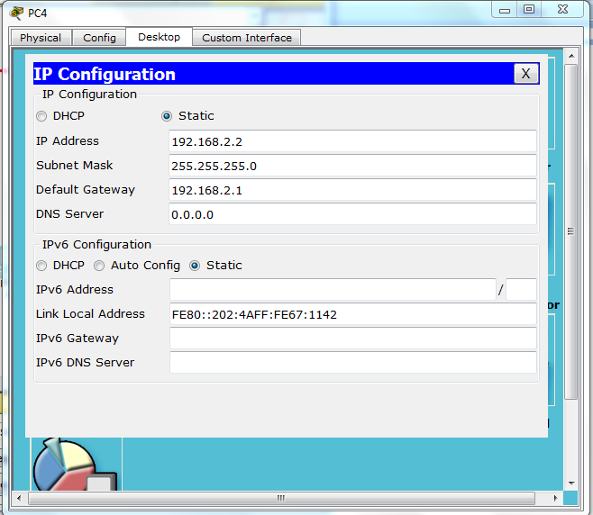

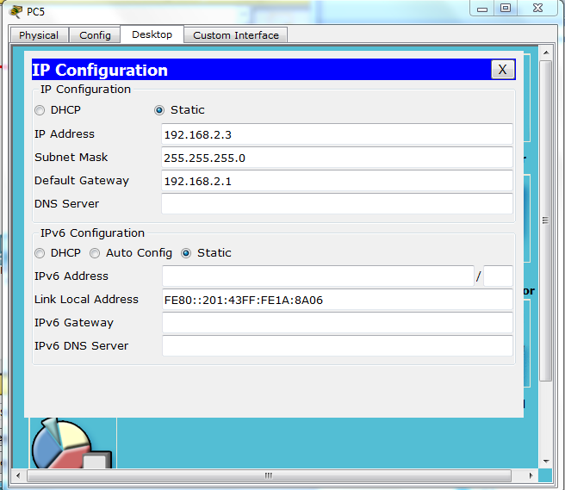

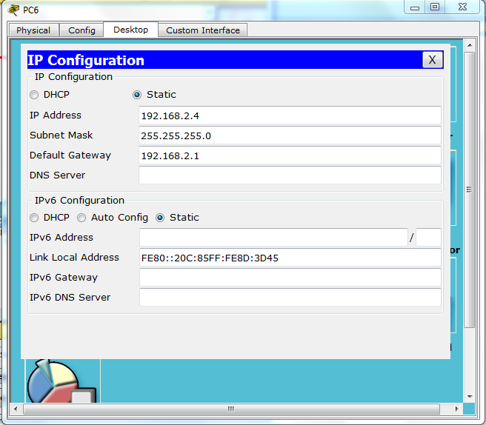

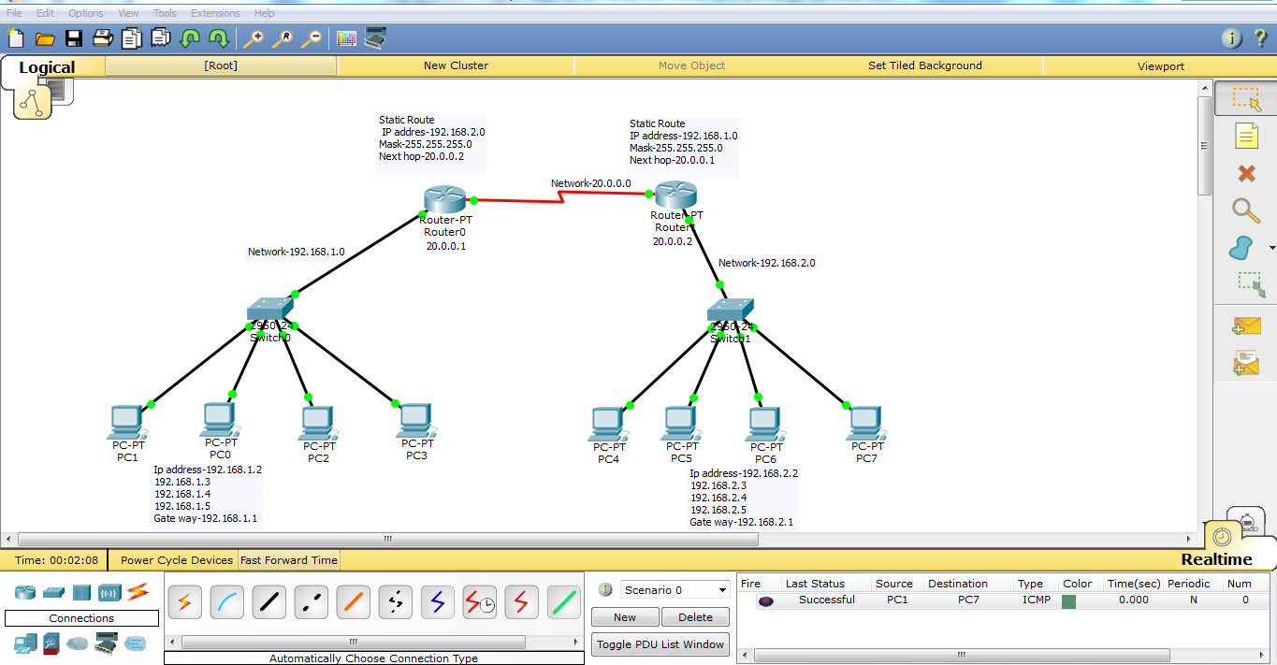

Click on PC0 and then click PC7. On the lower right of the screen you will see a message box that says “Successful.”

* **Output Analysis:**

(Students should write output analysis based on the working of different topology and different networking devices used in simulation. Specify each scenario explicitly with output analysis)

* **Additional Learning:**

(Students should write additional learning on their own based on what additionally they learnt after performing the experiment)

* **Conclusion:** (Students should write conclusion on their own)
* **Viva Questions:**
* What is the difference between star topology and bus topology?
* State advantages and disadvantages of each of star, bus, ring, mesh.
* Perform the experiment for ring topology and draw your own conclusion.
* State the working difference between hub and switch.
* **References:**
  + A.S. Tanenbaum, “Computer Networks”, Pearson Education, (4e)
  + B.A. Forouzan, “Data Communications and Networking”, TMH (5e)
* James F. Kurose & K W Ross: Computer Networking: A Top Down Approach, Pearson Education (LPE).

* + https://nptel.ac.in/content/storage2/courses/106105080/pdf/M5L1.pdf
  + https://nptel.ac.in/content/storage2/courses/117105076/pdf/5.1%20Lesson%2015.pdf
  + <https://www.netacad.com/courses/packet-tracer>
  + <https://www.youtube.com/watch?v=A7kOCHdfYtw>
  + <https://www.youtube.com/watch?v=PmDmRbz7EHM>